**Project Info**

Game: Unreal Tournament

Genre: First Person Shooting

Engine: Unreal Engine 4

Development Time:

Platform: PC

**Design Goal**

The player's goal is to have the highest number of kills at the end of the game. The map is designed to be fairly open and consists of shelters, armors, and other resources to ensure players' survivability.

**Overview**

This is a map designed for a four-player deathmatch using the Unreal Tournament Editor. It is a first-person shooting game that focuses on winning by obtaining the highest number of kills. The map consists of three levels: the underground tunnel, 1st floor, and 2nd floor. The setting of the map is in the ruins of a futuristic secret site located within the desert.

**Weapons and Pickups**

| **Weapon** | **Pickups** |
| --- | --- |
| Link gun  Sniper  Rocket Launcher  Rifle | Medium Health  Small Health  Thigh Pad  Chest Armor  Shield Belt  Helmet |

**Map**

1st Floor 2nd Floor 3rd Floor

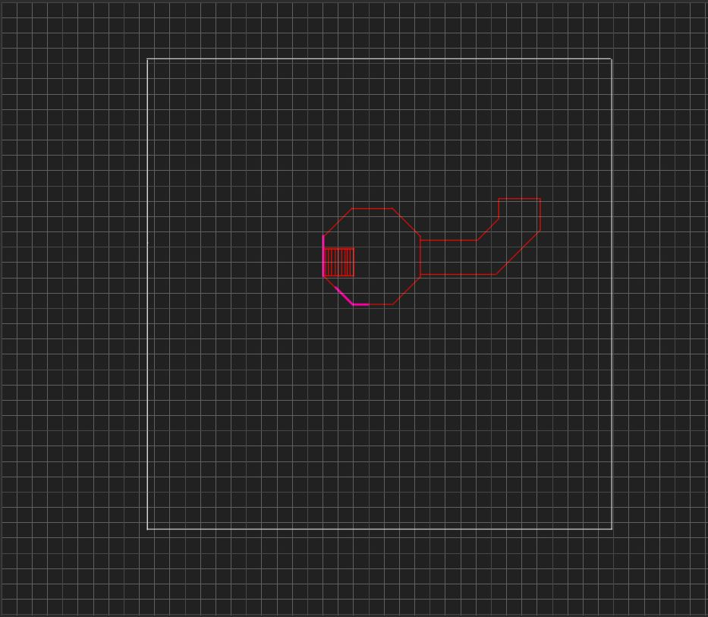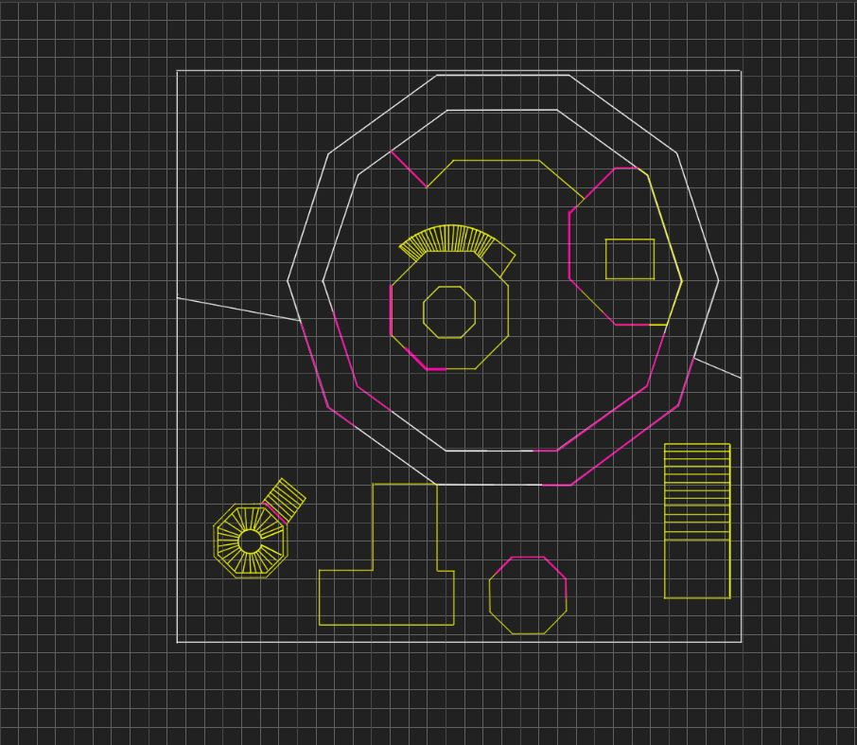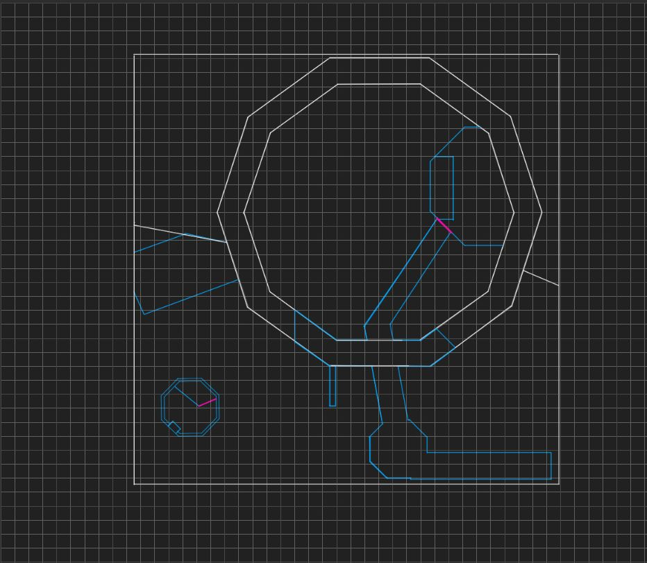

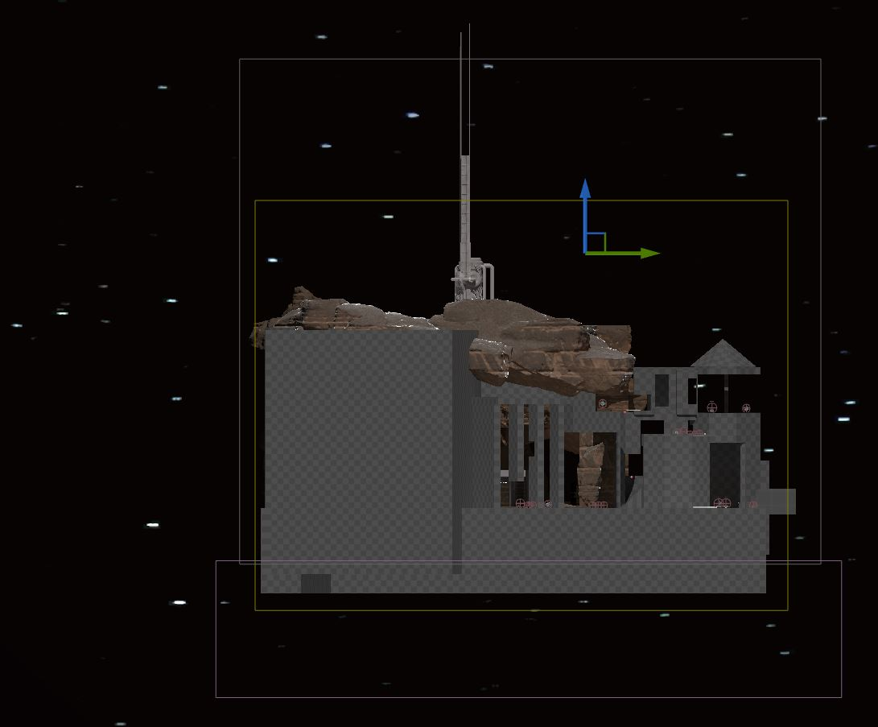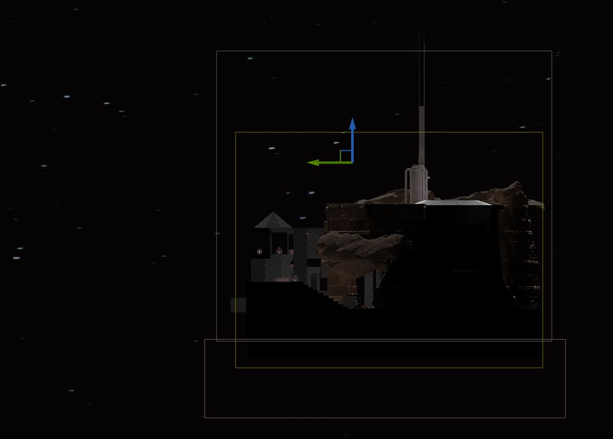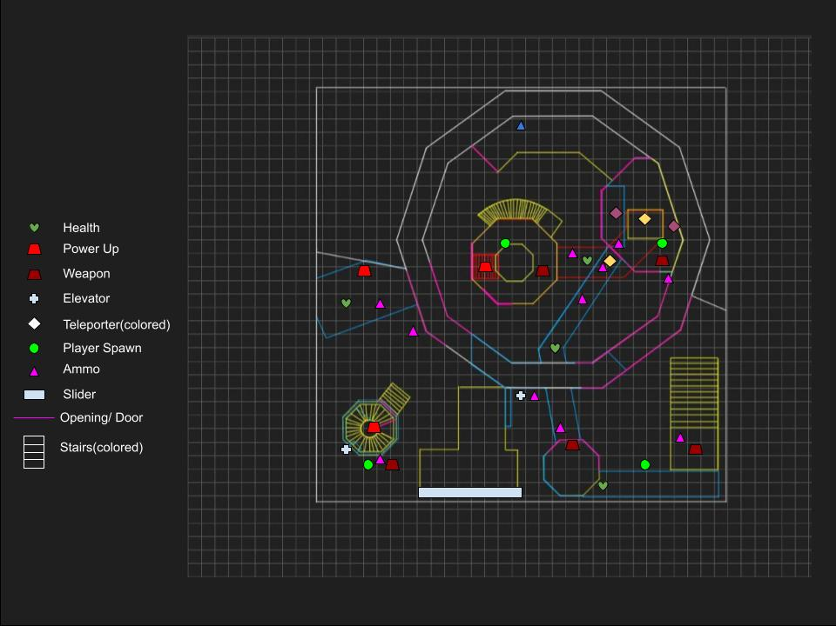

This map consists of three levels, with the first being the underground mining site and the second and third set above ground. Players will spawn on the first and second floors, with resources located near the spawn point that players can equip to increase their survivability.

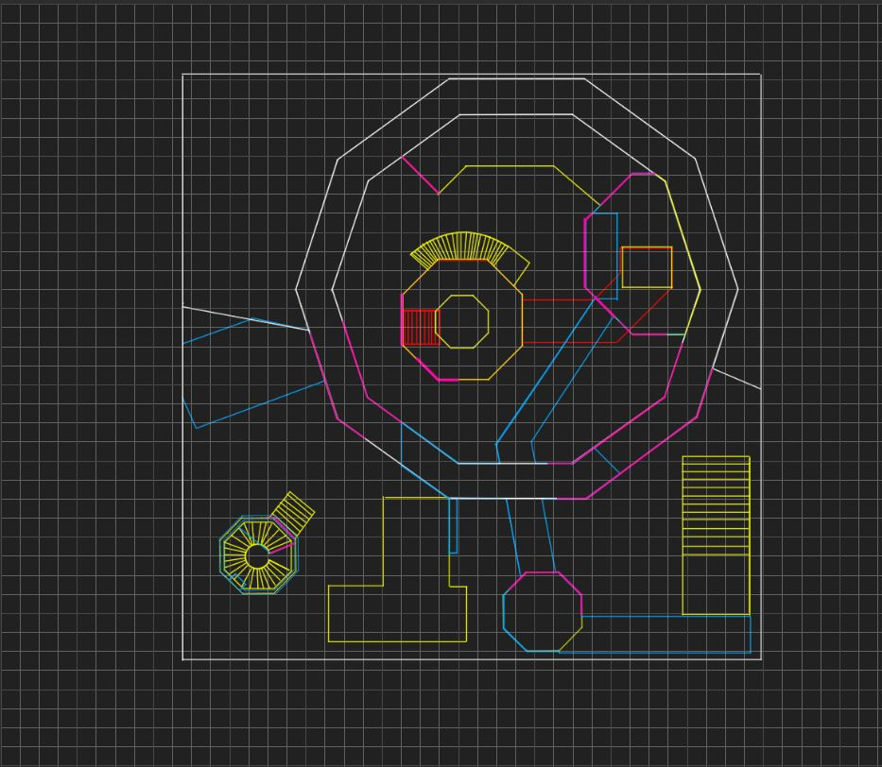[May include a map walkthrough video]

1. There are a total of four spawn points located on this map.
   1. The first one is located in the underground portion of the center island, and players can choose to travel through the tunnel located on the east or go up the stairs to the second level.
   2. The second one is located at the main building area on the east side of the map. Players can go down into the tunnel through the hole located on the west of the spawn point or leave the main building by going to either the north tunnel or the south door. They can also teleport to the second level of the building through the teleporter located next to the spawn point.
   3. The third spawn point is located near the southwest tower. Players can choose to go up the tower using the elevator next to the spawn point or glide across using the slider located on the east of the spawn point. They can also venture out to the open field.
   4. The fourth spawn point is located near the southeast tower. Players can use the slider located on the west to get across or venture out into the open field in other directions. There is also an elevator located on the north side that players can take to reach the balcony on the third floor.

**Playthrough and Screenshots**

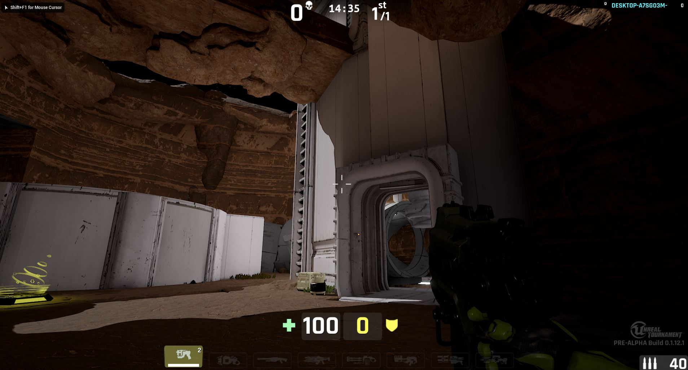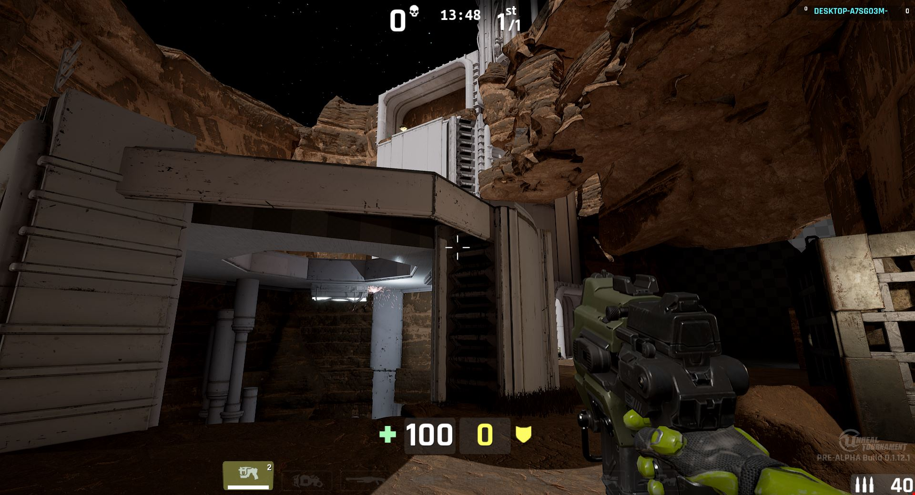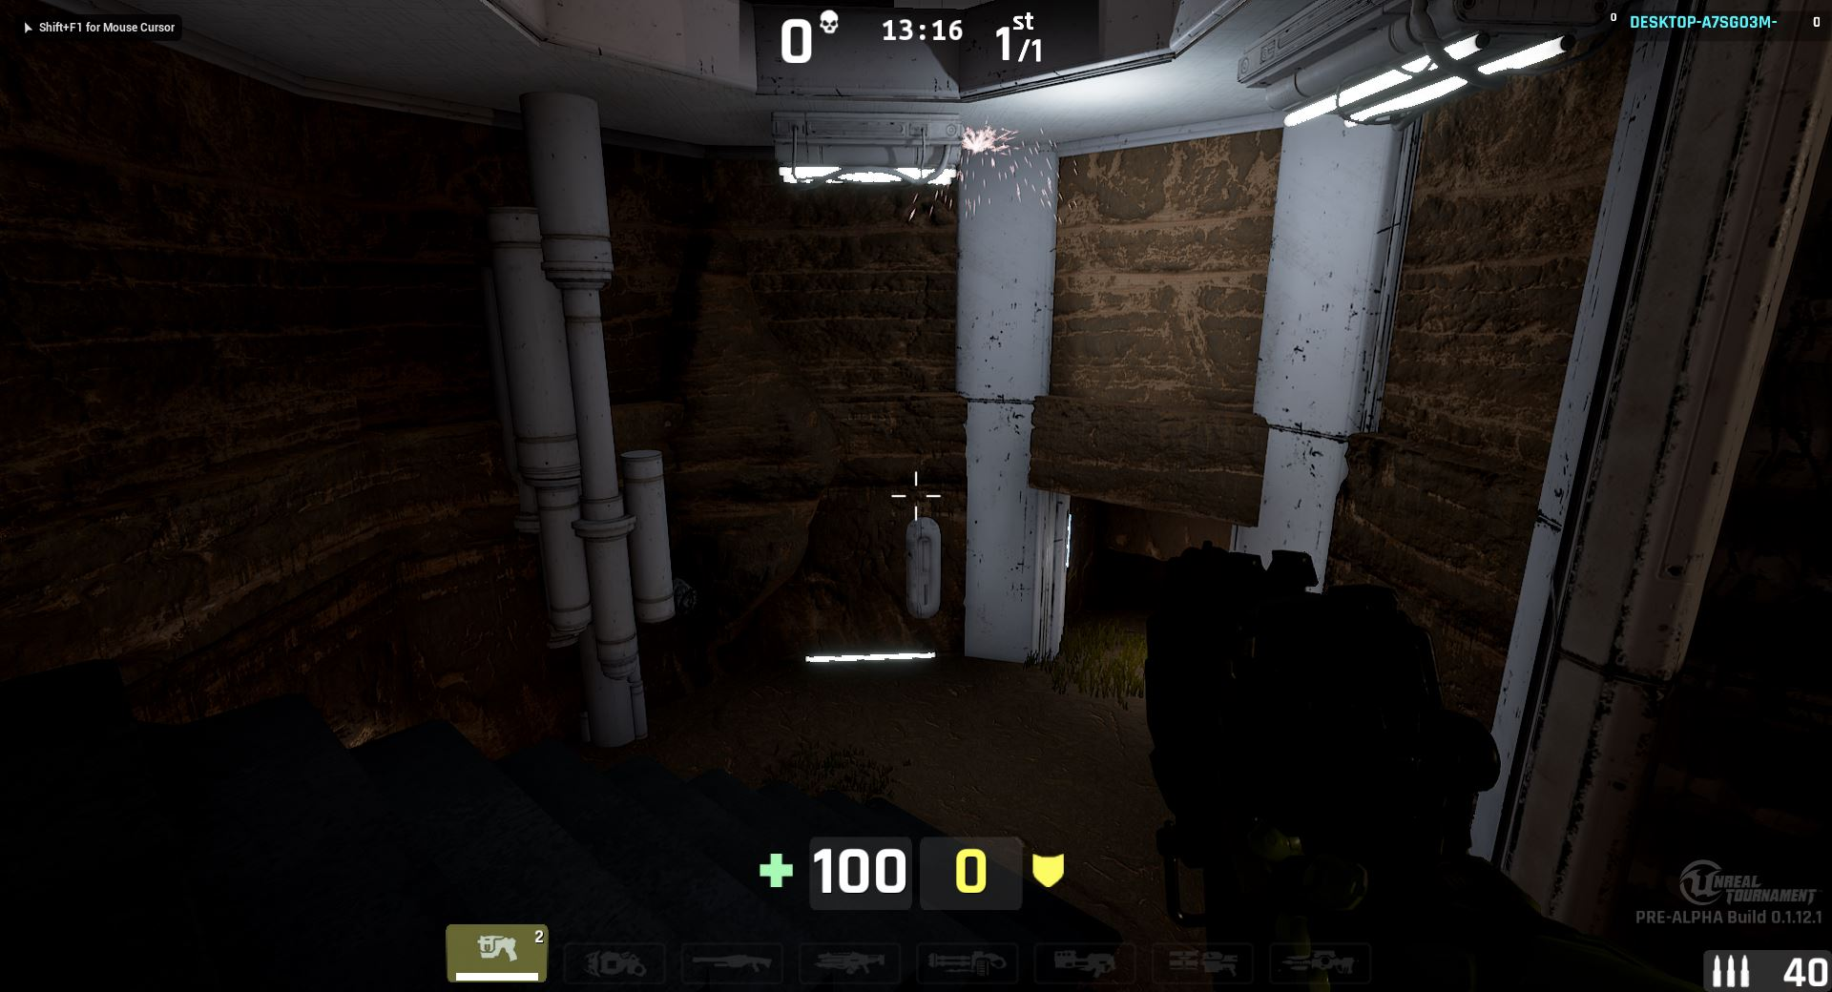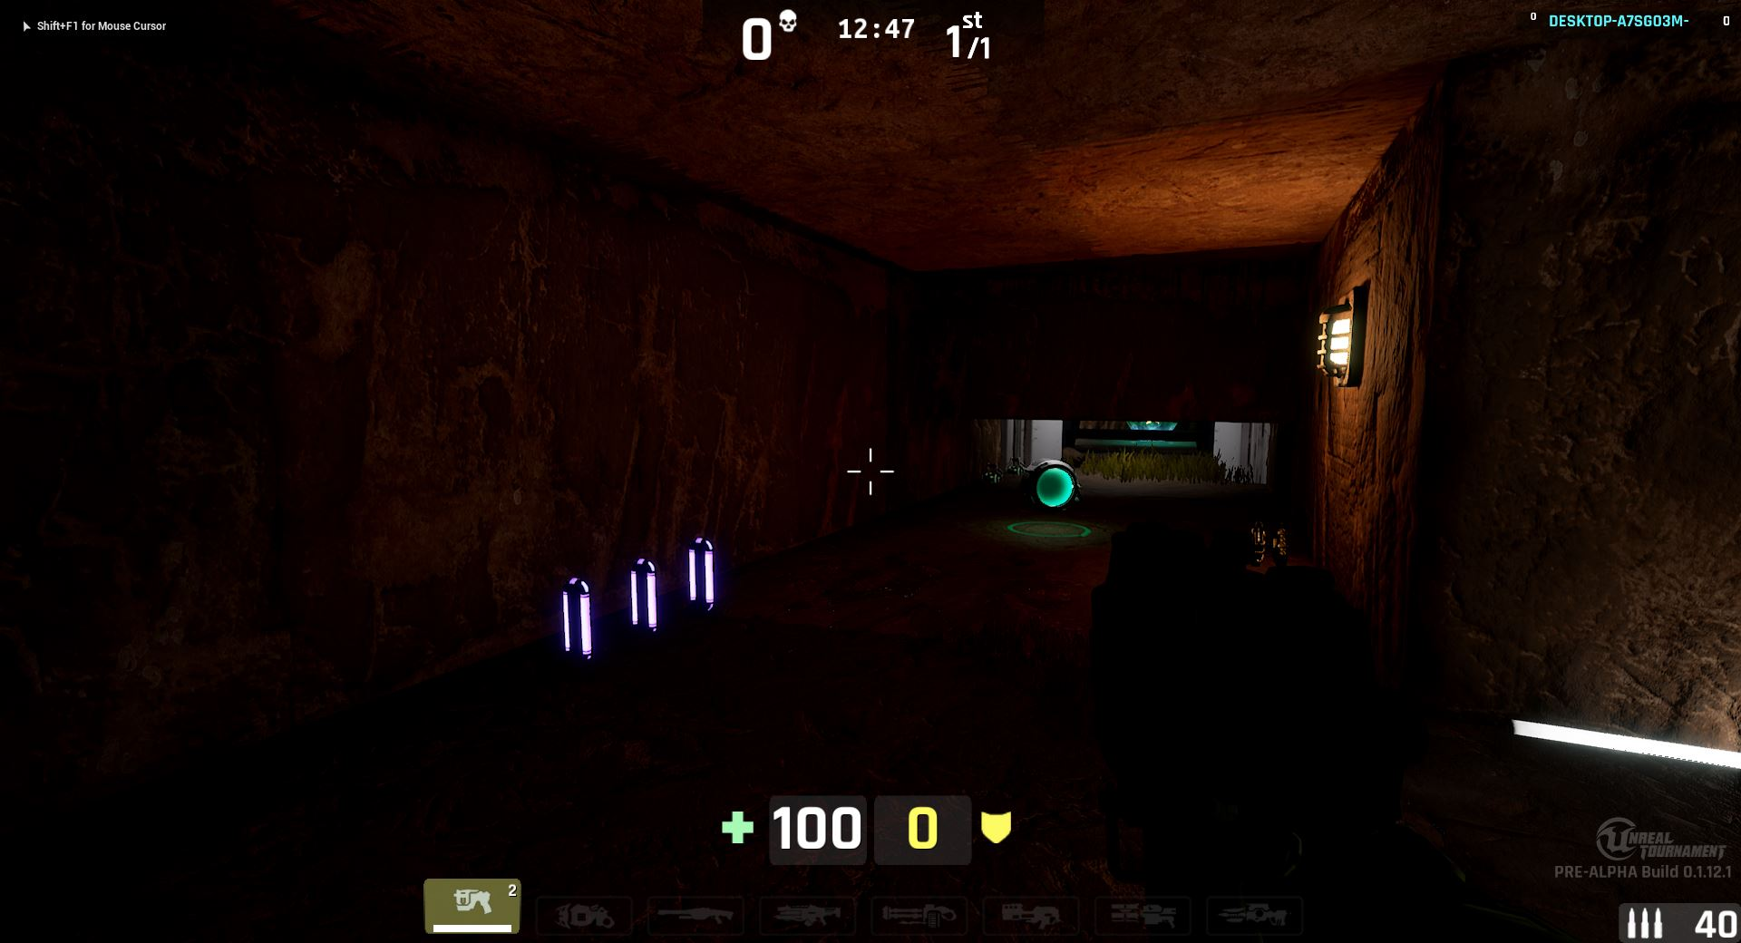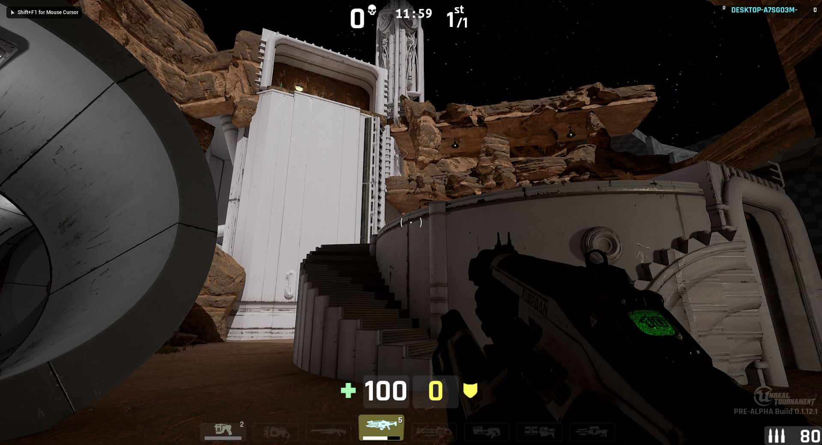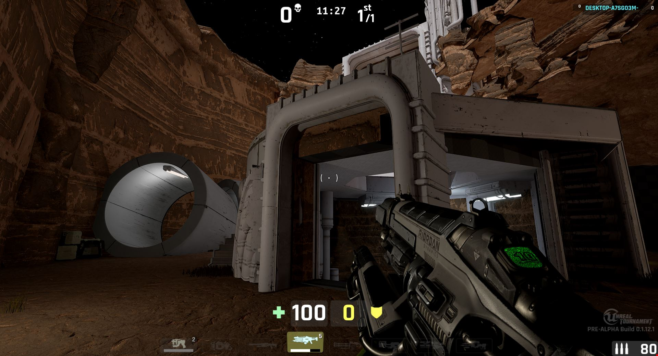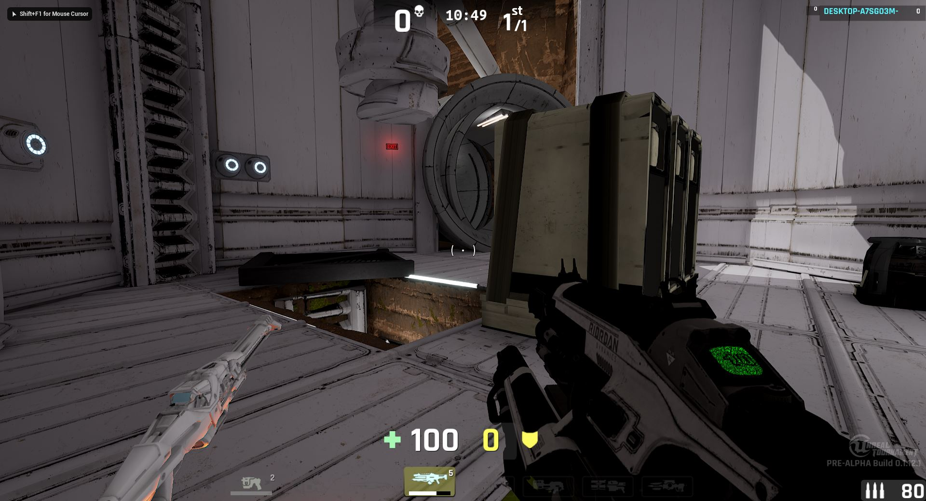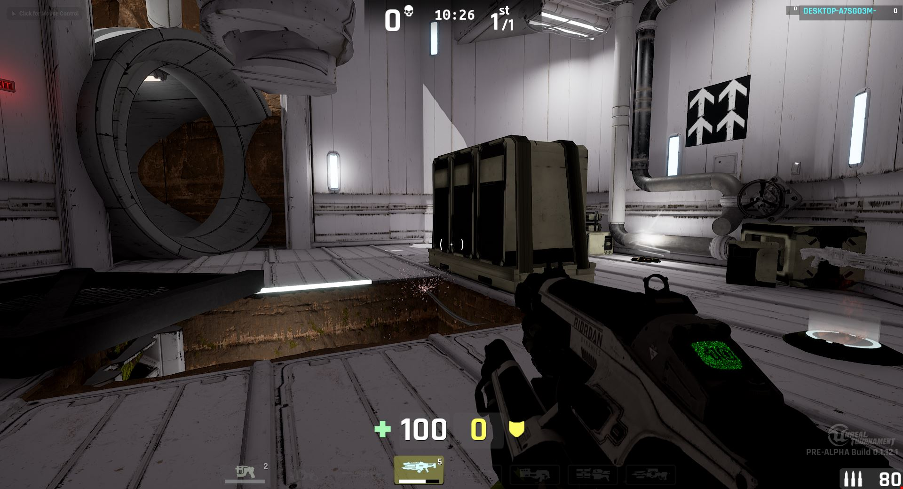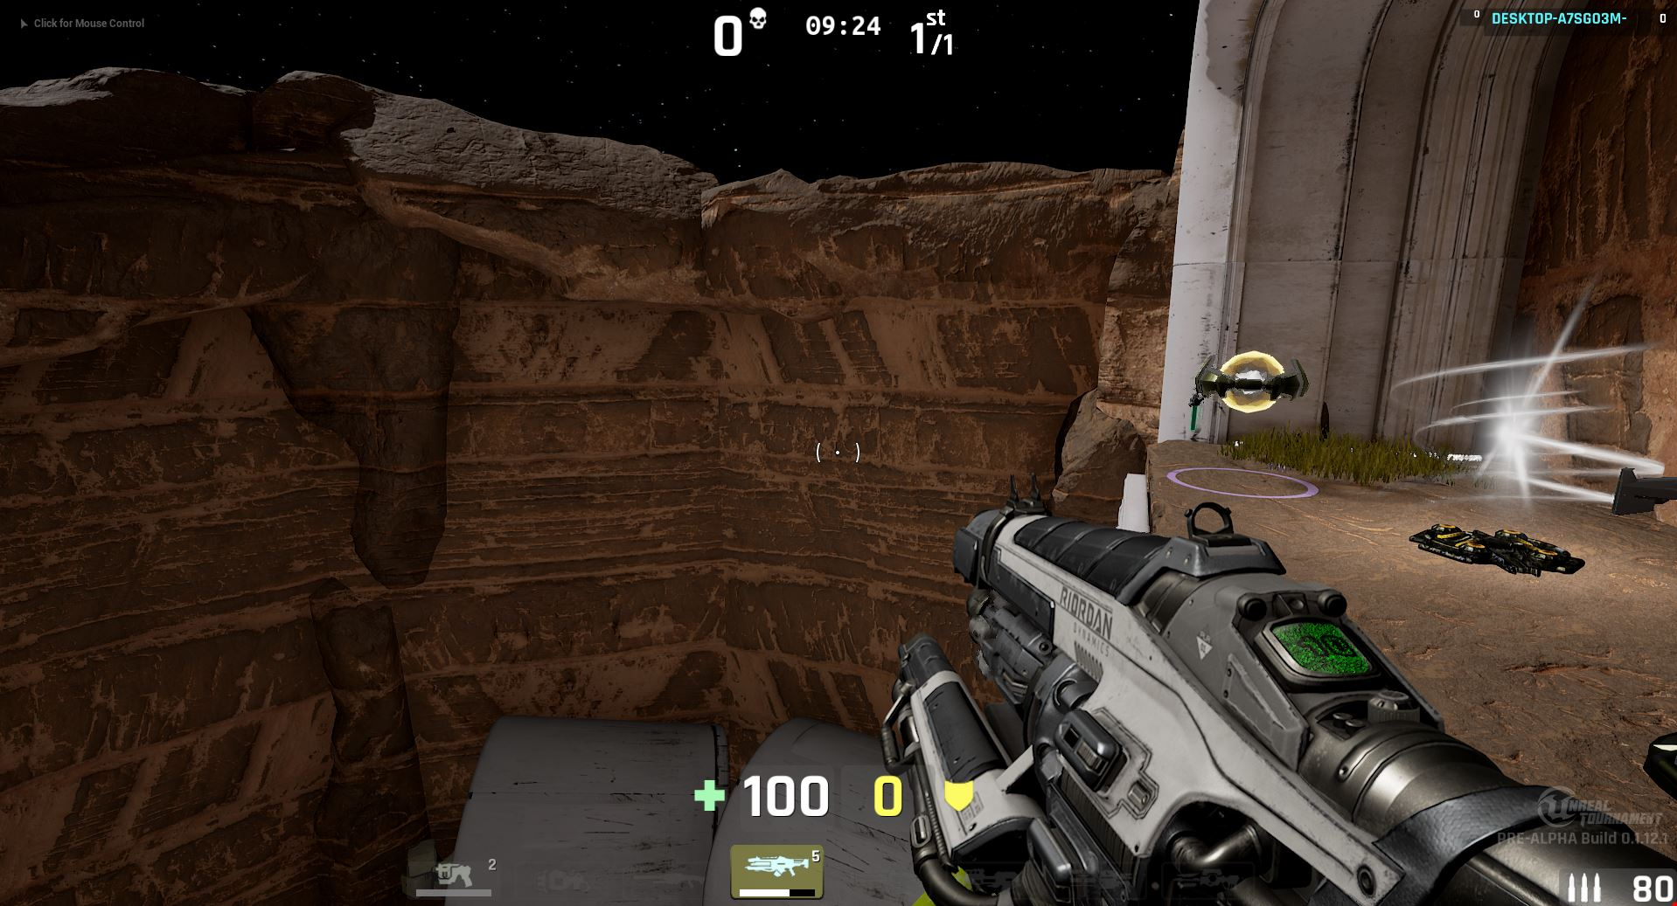

**Workflow**

| **Map Version** | **Screenshot** | **Major Structural Changes** |  |
| --- | --- | --- | --- |
| **1** |  | This is the first version of the map, which I started as a basic white-block game design. This map version includes two towers at the top left and right bottom, which I deleted for my later versions. The towers both include teleporters that allow players to go to the tower's upper level. They also have powerful weapons that will encourage players to try to go up despite the danger they may encounter. The initial reason was to make something that stood out as a special landmark and was meant to house powerful weapons for the player, considering the danger they may face while trying to grab it during the gameplay. |  |
| **2** |  | Through my first round of testing, I found that the underground bunker was too narrow for players to safely travel in and out of it. Changes must be made to it. Additionally, although I tried to create a second level for my map, it is still lacking. Therefore, I added an additional bridge between the building at the top right and the platform on the cut-out wall. I also made a few holes in my first tunnel to allow players to enter from multiple points. |  |
| **3** |  | I created an underground tunnel inside the middle island and removed the two tallest towers. Instead, I added a small tower at the bottom as a sniper site for players. Additionally, I raised an extra platform for snipers to shoot from. By raising the wall next to it, players can avoid being easily sniped. Another wall is also added next to the outer elevation for the same purpose. Furthermore, I reduced the space on the second level of my central building to prevent players from staying in one location for too long during gameplay. The previous design was too spacious and resourceful, giving players less reason to leave it. |  |
| **4** |  | To provide more room for players to move around, I moved the center island further north. The underground tunnel is now complete with a halfway block that requires players to crouch to get through, connecting the center island to the central building. I also added a wall that makes players crouch when passing through, creating more variety in the gameplay flow. To make sniping more challenging, I added a second-level balcony to create more hiding spots, including a higher balcony on the first floor. I removed the previously raised platform next to the door because it felt unnatural during testing, and players had a hard time getting on it due to the angle of the platform. |  |
| **5** |  | To make it even more challenging for snipers, I added multiple blockades on the balcony. Additionally, a raised platform near the southwest corner of the balcony was added to house the rocket launcher. The southwest tower was also modified with the installation of an elevator and stairs, making it easier for players to access and escape. To allow players to travel through the outer wall when coming down from the balcony, I added an opening on the east side. An opening was also added to the center island to create a more spacious feel when players are running past it. |  |